CURRICULUM-VITAE
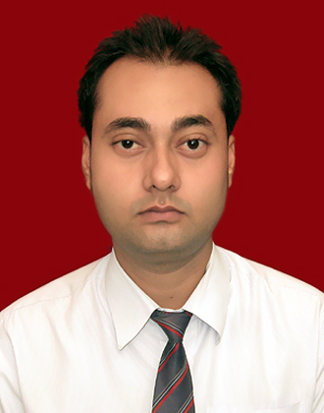

Name: Prabhakar Dwivedi

Contact Number: 09452204651

E-Mail Address: princedwvd26@gmail.com Career Objective: Looking for long-term association with a people oriented organization
where, an individual skill, honesty talents and hard work/ smart work are
acknowledge and conducive work culture is provided.

Key Skills:
- Innovative.
- Positive Attitude.
- Good In Building And Maintaining Relationship.
- Problem Solving Ability
Strengths:
- Managerial and organizational skills.
- Grasp the new skills quickly.
- Responsible towards work.
- Self-motivated and directed
- Willingness to learn
Professional Qualification:
- MBA (2011-2013) from Shri Ramswaroop Memorial College Of Engineering and Management,Lucknow .
Area Of Specialization:
- Marketing (major) and Finance (minor)
Academic Qualification:
- BBA (2008-2011) from Shri Ramswaroop Memorial College Of Engineering and Managrment,Lucknow,
- XII Commerce (2008) from Red Rose Senior Secondary School,Lucknow,
- X Science (2006) from Red Rose Senior Secondary School,Lucknow .
Work Experience:
Company: White Wings Security Services.
Profile: Customer Relation Officer.
Experience: From 2nd May 2016 till date.
- Talking to customer and generating leads.
- Configuring the systems as per customer requirements.
- Handling customer queries.
- Handling the team.
Computer Skill:
- Diploma In Computer.
- Tally ERP.9 advanced version.

Summer Training Project:
- MBA
- Six Weeks Training On” Analysis Of Marketing Strategy Of MTS” From The MTS Company.

- BBA
- Six Weeks Training On “In Which Area More Focus Of Marketing And Operation” From The Punjab And Sind Bank.
Extra Curricular Activities:
- Participated as a volunteer in management fest ‘LAKSHYA’2012 during MBA.
Personal Details:
Date Of Birth: September 05, 1989
Mother’s Name: Mrs. Prema Dwivedi
Father’s Name: Mr. O.P. Dwivedi
Interest: Playing chess, cooking and travelling.
Permanent Address: 3/125 Vishesh Khand Gomti Nagar Lucknow

DECLARATION:

The above mentioned information is true and correct to the best of my knowledge and belief. If I am selected and given a chance to serve in your esteemed organization I shall prove my best and ability to the entire satisfaction of my superiors.

Date:

Place:

(PRABHAKAR DWIVEDI)

Contact Us
Top of Form
Bottom of Form

